**Usecase diagram:**

To model a system, the most important aspect is to capture the dynamic behavior. Dynamic behavior means the behavior of the system when it is running/operating.

Only static behavior is not sufficient to model a system rather dynamic behavior is more important than static behavior. In UML, there are five diagrams available to model the dynamic nature and use case diagram is one of them.

The use case diagram is dynamic in nature, there should be some internal or external factors for making the interaction.

These internal and external agents are known as actors. Use case diagrams consists of actors, use cases and their relationships. The diagram is used to model the system/subsystem of an application.

 The purposes of use case diagrams can be said to be as follows −

* Used to gather the requirements of a system.
* Used to get an outside view of a system.
* Identify the external and internal factors influencing the system.
* Show the interaction among the requirements are actors.

Actors can be a human user, some internal applications, or may be some external applications. When we are planning to draw a use case diagram, we should have the following items identified.

* Functionalities to be represented as use case
* Actors
* Relationships among the use cases and actors.

After identifying the above items, we have to use the following guidelines to draw an efficient use case diagram

* The name of a use case is very important. The name should be chosen in such a way so that it can identify the functionalities performed.
* Give a suitable name for actors.
* Show relationships and dependencies clearly in the diagram.
* Do not try to include all types of relationships, as the main purpose of the diagram is to identify the requirements.
* Use notes whenever required to clarify some important points.

Example:

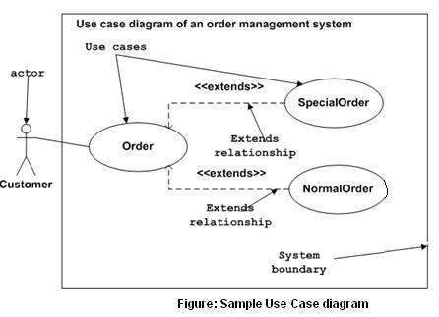

Use case diagrams can be used for −

* Requirement analysis and high level design.
* Model the context of a system.
* Reverse engineering.
* Forward engineering.

In forward engineering, use case diagrams are used to make test cases and in reverse engineering use cases are used to prepare the requirement details from the existing application.